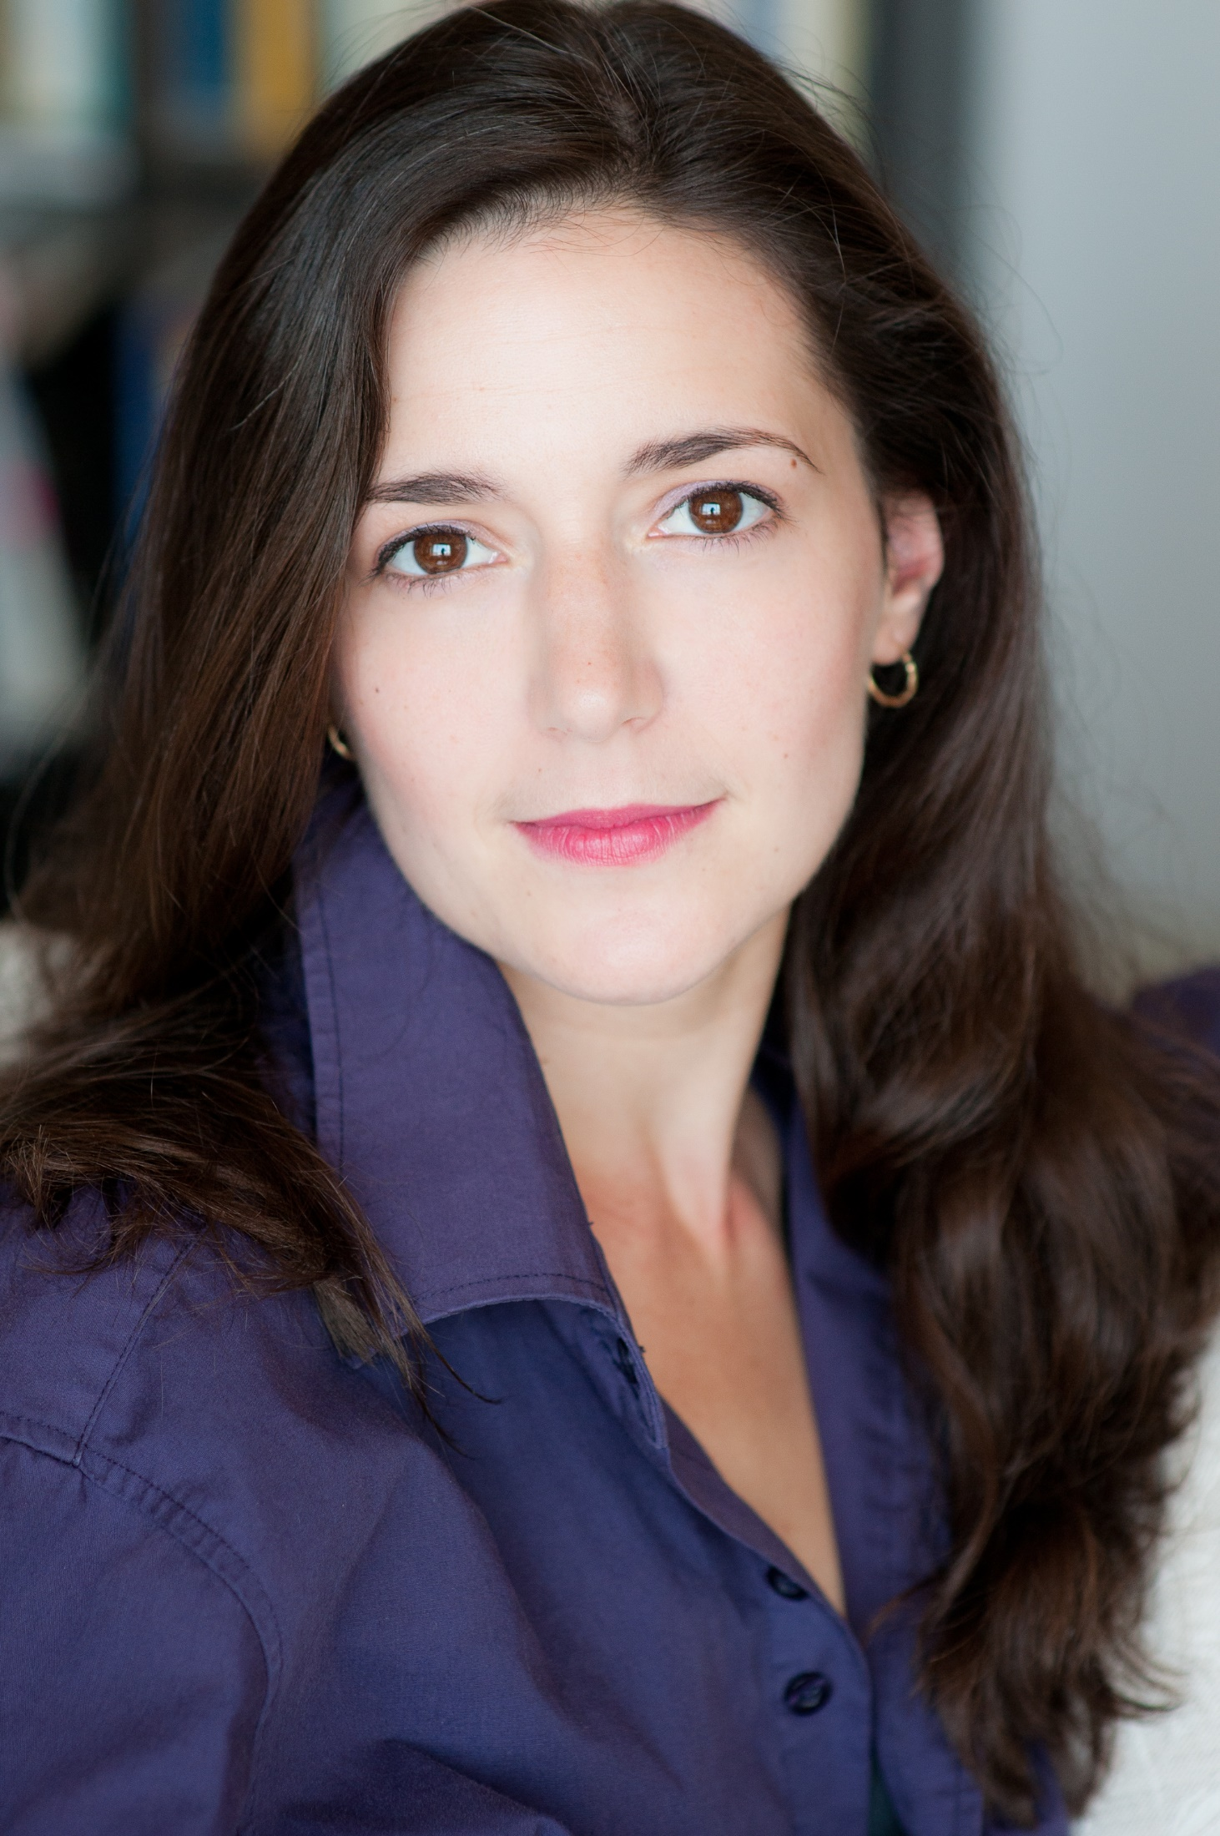

ANANDA

BENA-WEBER
Associate Artistic Director: Sierra Nevada Ballet
Official Adjudicator, Regional Dance America
ABT Curriculum Certified Teacher

Website: anandabenaweber.com
Mobile: (917) 331-2773
Email: anandabenaweber@gmail.com

Member: AEA, IADMS,
Board Member: NAPAMA

Height: 5’7”

Ananda Bena-Weber has been teaching in schools and universities throughout the US and abroad for 26 years. She teaches a variety of subjects including many forms of dance, physical acting, mime, clown, and Shakespeare. Ms. Bena-Weber was a professor of dance at Marymount Manhattan College, and a teaching artist for the Dance Theater of Harlem and Mark Morris Dance Center in New York for 16 years.

Teaching Experience

Marymount Manhattan College 2004-2017  professor of practice, ballet, tap, jazz, musical theatre, adv pointe in tasked with choreography of musicals, reviews, performances at the York Theatre NYC several times per year. | Dance Theater of Harlem 2009-2016  teaching artist: Dancing Through Barriers Curriculum, STEM, Literacy,  ballet for boxers, ballet for basketball players
Mark Morris Dance Center 2009-2017  substitute teacher all levels ballet, tap, jazz, teaching artist | Alonzo King Lines Ballet 2016-present  Int/Adv ballet, teens 2/3, pointe
Sierra Nevada Ballet 1998-present  all levels ballet, pointe, pas de deux, character, mime, rehearsal coach | University of Nevada at Reno  Classical Ballet, Pointe
Pittsburg State University -Artist Residency  Advanced tap, mime, physical acting | Eagle Hill School, Hardwick MA -Artist Residency  Beginning ballet, beginning tap, mime, clown, public speaking, Shakespeare (12th Night)
Clark University, Worcester MA -Artist Residency  Physical acting, Fosse- style jazz dance | Allen Community College, Iola KS -Artist Residency  Mime, clown, physical acting
Summer Intensive with Mariana Tcherkassky  Character | Deane Dance Center, Sacramento  Classical ballet, pointe, character
Dance Alliance Roosevelt Island NY  Jazz, ballet, tap | Honey Dance Center Queens NY  classical ballet
In Motion Studio of Dance (NV)  Classical Ballet, pointe, character | In Motion Dance (CA)  Classical Ballet, pointe, stretch and strengthening
Westchester Conservatory of Ballet  All levels ballet | Louisiana Delta Ballet  Classical ballet, pointe, variations
Western Nevada Performing Arts Center  Classical Ballet | San Mateo Gymnastics Group  Ballet technique combined with functional exercise as injury prevention, alignment, and flexibility training for Olympic gymnasts. Levels 5-10 and Elite.
Chabot Skate Club  Ballet for Figure Skaters | California Academy of the Performing Arts  tap levels 1-4
Peninsula Ballet Theatre School (CA) 1994-2003  Classical Ballet: Elementary Levels 1-5, Intermediate, Advanced, Pointe, Character, ‘Body Reshaping’ (Mensendiek method of functional exercise) | Tansacademie Cifuentes (Berlin Germany)  All levels Ballet
Bremerton Dance Center (Seattle)  Ballet, character | Dance Masters of America  Ballet
Dance Educators of America  Ballet, character | Assisi Institute, Mystic, CT  Movement theory and group dynamics
Bob Macke Studios (CA)  Classical Ballet: Elementary Levels 3-4 | Brewery Arts Center, Carson City  Improvisation workshop
‘Dance Attack’ Mountain View  Classical Ballet: Elementary Levels 1-3 | ‘Dance Attack’ Los Gatos  Classical Ballet: Intermediate
Charlotte Klein Dance Academy (MA)  Tap, ballet | East Bay Dance Company  All levels Ballet
Calment High School (CA)  Understanding Shakespeare (tutoring) | Myong Moon Institute (CA) - English as a second language, Essay writing

Education

- Goddard College MFA
Interdisciplinary Arts
- Columbia University Acting MFA Program (INC)
- San Francisco State University BA - (Russian Language/Literature, Theatre Arts)
(received acting scholarship in 2002)
- Shakespeare and Co.
Winter intensive
- Moscow Art Theatre School
Summer Intensive
- Linklater Center for Voice and Speech
- Rossika Language Institute St. Petersburg Russia - Contemporary Russian Literature
- Hydro-Meteorological University, St. Petersburg Russia
Russian Grammar and Composition
- Balliol College at Oxford University, British American Drama Academy’s Midsummer in Oxford
Shakespeare
Intensive group
- College of San Mateo – Human Anatomy and Cadaver Dissection, Biology
- American Conservatory Theatre -Youth Conservatory
- Extensive training as a professional dancer. (See ‘Instructors’ section)

Choreographic Experience: Full Length Productions:

“Twelfth Night A Ballet Noir”
Sierra Nevada Ballet, full length flagship production. This full-length ballet features a musical collage created by Bena-Weber using music from different famous films noir, and starred artists from the Royal Danish Ballet, National Ballet of Mexico, the Joffrey Ballet, and Oklahoma City Ballet.

“A Steampunk Midsummer Night’s Dream”
Sierra Nevada Ballet, full length flagship production. This full-length ballet directed, devised, and choreographed by Ananda Bena-Weber featured the music of 4 Mendelsohn symphonies combined with the music of Martin Denny and Les Baxter from the Hypnotique and Exotica Era of the 1940’s. This production featured dancers from the Joffrey Ballet, Ballet Hispanico, San Francisco Ballet, Dance Theatre of Harlem, Oakland Ballet, and Smuin Ballet. The production was featured on the television show ARTEFFECTS.

Musical Theatre/Short Pieces:
“Sway”  Sierra Nevada Ballet, male solo | The Grand Tour”  The York Theatre, NYC
“Kleinkunst”  National Yiddish Theatre | “Love!”  Marymount at the York Theatre
“Hungarian Suite”  Sierra Nevada Ballet | ‘Take Me Along’  The York Theatre, NYC
“Sweet Bye and Bye”  The York Theatre, NYC | “We Sing.”  Marymount Manhattan College
“That’s It. I Quit”  Marymount Manhattan College | “Come Together”  Marymount Manhattan College
“The Story of Ferdinand”  Dance Theatre of Harlem Literacy through Dance | “Song of Myself”  Dance Theatre of Harlem artist residency
“Romeo and Juliet”  Sierra Nevada Ballet | “Swan Lake” (character dances)  Sierra Nevada Ballet
“Summertime”  Sierra Nevada Ballet | “Ronen”  Sierra Nevada Ballet
Armando’s Rumba  Sierra Nevada Ballet | Classical Doodles  Bruka Theater

(as well as numerous student productions, weddings, and social events)

Performance Experience
Fancifool! With Ananda Bena-Weber  WINNER! Best Variety Show, Theatre Row, NYC!,  WINNER! Best of Genre, Marsh Theatre, SF! | Fancifool! SEX EDITION  National Tour
TED Talk: ‘CommUNITY’  TED - “Ideas Worth Spreading” Check it out online! | American Tap Masterpieces  Jazz Tap Ensemble, Joyce Theatre NYC-Ginger Rogers, Eleanor Powell
Jazz Tap Ensemble  Los Angeles Tour –Featured Dancer | Artown Festival Reno  Featured performer at every Artown Festival since the very first year!
The Vagina Monologues  National V-Day Celebration –The Woman Who Liked to make V’s Happy | The Fallen  T-Schreiber Studio Theater -Sabine
Ten Blocks On the Camino Real Medicine Show Theater –Marguerite | Classical Doodles  Bruka Theater –commissioned one woman show
The Scholars Weigh In  Clark University –solo piece | The Unicorn Gorgon and Manticore  Nevada Opera -Countess
Romeo and Juliet  Sierra Nevada Ballet - Juliet | The Dying Swan  Sierra Nevada Ballet – Swan
Too Darn Hot  Sierra Nevada Ballet - Lead principal with Domingo Rubio | Allegro Agitato Sierra Nevada Ballet - Lead Principal
Gershwin Prelude  Sierra Nevada Ballet -pas de deux with Domingo Rubio | The Butcher  Gulfshore Playhouse, Naples Florida –Sholeh Esfahani
Hamlet  Nevada Shakespeare Company – Ophelia, Horatio | Richard III  Nevada Shakespeare Co. –Lady Anne, Duchess of York
As You Like It Shakespeare and Co. Winter Intensive final project -Rosalind | The Seagull  Moscow Art Theatre School - Arkadina
The Last Dance (film)  Sacha Goldberger dir. -NYU | Duke Ellington Jazz Nutcracker  The Reno Jazz Orchestra –Sugar Rum Cherry
Outlet Dance Project  Solo Piece for Seward Johnson sculpture ‘Olympia’ | Outlet Dance Project  Solo Piece for Seward Johnson sculpture ‘God Bless America’
Summer Time  Sierra Nevada Ballet - duet with Sam Weber | Back Street  Tap duet with Sam Weber
Ronen  Sierra Nevada Ballet – Russian character solo | A Painter’s Love Story  Sierra Nevada Ballet - lead Principal, Lydia Parrish
Crave  by Sarah Kane, Columbia University - A | Homewrecker  by Kelly Stuart, Columbia University
Oresteia  Euripides, Columbia University – Clytemnestra | Medea  Sophocles, Columbia University - Medea
Blue Rondo A La Turk  Tap duet with Sam Weber | Les Sylphides  Sierra Nevada Ballet - Lead Principal
The Trojan Women  San Francisco State University – ‘Andromache’ | Daisy in the Dreamtime  San Francisco State University – ‘Daisy’
New York, New York  Fascinating Rhythm Productions – Featured Dancer | Paul’s Case  by Willa Cather, San Francisco State University – ‘’Paul’
People of Paris  Fascinating Rhythm Productions – Featured Dancer | Shakespeare Salad  San Francisco State University- Actor, Writer, Co-Director
Richard III (Film)  David Hunt - British American Drama Academy – ‘Lady Anne’ | Tap Concerto  Morton Gould with Sam Weber, The Peninsula Symphony Orchestra – Tap Soloist
Tap Concerto  Morton Gould with Sam Weber, The San Jose Symphony Orchestra – Tap Soloist | Scheherazade  The Reno Ballet-featured soloist
Take Me to the River  The Reno Ballet –soloist | Orbit of the Seasons  The Reno Ballet-corps de ballets
Walking on Broken Glass  Perspective Dance Theatre –corps de ballets | Fools  by Neil Simon, San Mateo Performing Arts Center – ‘Lenya’
Nine  San Mateo Performing Arts Center -Luisa | Arsenic and Old Lace  San Mateo Performing Arts Center— ‘Dr. Einstein’
Damn Yankees  San Mateo Performing Arts Center– ‘Lola’ | A Midsummer Night’s Dream  San Mateo Performing Arts Center – Helena
Tap Concerto  Morton Gould with Sam Weber, The Livermore Philharmonic -Tap Soloist | Dave Brubeck Medley  with Sam Weber, The Peninsula Symphony Orchestra – Tap Soloist
Dave Brubeck Medley
with Sam Weber, The San Jose Symphony Orchestra –Tap Soloist

Industrials/Commercial

- Dance Retailer News Expo,
Las Vegas, Les Sylphides –
Guest Principal Dancer
- Harrah’s Hotels and Casinos
Guest Artist
- Hornblower Yachts
Guest Artist
- Fairmont Hotels
Featured Performer
- San Francisco Spirit Cruises
Guest Artist

- Visa Corporation International Convention
Featured Performer
- Arts All Ways Conference Las Vegas, Nevada Arts Council, (2 Woman Show)
- World Wide Web Convention
Featured Dancer
- Miki Corporation International Convention
Featured Performer
- Sun Microsystems
Guest Artist

Writing/Directing/Coaching Experience

- “Twelfth Night: A Ballet Noir” Sierra Nevada Ballet -director/choreographer/musical collage
- “A Midsummer Night’s Dream’ Sierra Nevada Ballet -director/choreographer/musical collage
- “Fancifool! with Ananda Bena-Weber Writer/ Concept/Featured Performer
- “The Scholars Weigh In” Writer/Concept/Featured Performer
- “Classical Doodles” Bruka Theatre -writer/concept/featured performer
- “George’s Turn –the ballad of a song and dance Man”
Starring George Marcy - director
- “The Actual Dance” Starring Sam Weber - director

“Ballet By the River”

Sierra Nevada Ballet -director
- An Evening of Gershwin- starring violinist Janice Martin
Director/choreographer
- “Paging Mr. Stair”,
Sierra Nevada Ballet - Coaching

‘Without Breaking’, San Francisco State University

Author, Staging
- ‘Shakespeare Salad’, San Francisco State University
Writer, Co-Director

Set Crew and Costume Experience

- Nevada Shakespeare Company
ASM “Richard III”, “Hamlet”
- Columbia University
“The House of Bernarda Alba”- set crew
- Assisted in costume/set design- S.F State University

Training

Acting; Voice; Linklater Voice Technique; Clown; Classical Ballet; Pointes; Pas de Deux; Character; Mime; Flamenco; Jazz; Tap; Singing; Argentine Tango; Modern Dance; Ballroom; Stage Combat; Dance History; Kinesiology; Mensendieck Method of Functional Exercise; Alexander Technique; Feldenkrais, Creative Movement education

Dialects

British, cockney, Irish, Scottish, Russian, Iranian, Puerto Rican, German, French, Italian, East Coast US (various), Southern US (various), Mid-West US, California “Valley Girl”, and others

Impressions

Billy Holiday, Cher, Carol Channing, Yvonne Adair, Ethel Merman, Peggy Lee, Carmen McRae, Gwen Verdon, and others.

Languages

English, Russian, French (conversational)

Instructors

Ballet: Anne Bena, Rosine Bena, David Howard, Dorit Koppel, Alonzo King, Peter Schabel, Jack Hertzog, Sandra Chin, Christopher Lam, Simon Dow, Laura Connor, Summer Lee Ratighan, Arturo Fernandez, and others.
Acting: Kristin Linklater, Tina Packer, Kevin Coleman; Dennis Krausnick; Dave Demke; Terry Schreiber; Andrei Serban, Niky Wolcz, Larry Singer, Andrea Haring; Estelle Kohler, Joyce Henderson, David Hunt, Alice Spivak, William Peters, Camille Howard, Ronnie Washington.
Voice: Kristin Linklater, Andrea Haring, Elena McGee, Dave Demke, Milton Williams.
Mime: Rosine Bena, Joyce Henderson.
Stage Combat: Steven White, Edward Foy
Jazz: Luigi, Francis Roach, Berle Davis, Sam Weber.
Tap: Sam Weber, Berle Davis.
Character: Anne Bena, Rosa Laysaya.
Horton: Milton Myers, Jolea Maffei, Karen Arceneaux
Flamenco: Adela Clara, Miguel Santos.
Ballroom (Swing, Salsa, Tango etc.): Anne Bena, Adrian Bermudez.
Argentine Tango: Beatrice Cisneros, Santiago Steele, Nito and Alba, Paul Pellicoro.
Kinesiology; Mensendieck Method of Functional Exercise: Michael Keropian, Rosine Bena

